Program Organized by
Incubation Centre
Rajeev Gandhi Govt. P.G. College, Ambikapur Distt. Surguja

Index
S.N  . | Topic | Program | Sessio n | Program date | Pag e No.
1 | Population & Development with Specialreferenceto  Spiritual Socialism | Internation all Webinar | 2021-  22 | 11-12july  2021
2 | Innovation in Agriculture | Lecture | 2022-  23 | 8/12/2022
3 | Self-Employment,  Entrepreneurship&Financing | Internation all Webinar | 2021-  22 | 27January  2022
4 | Skill Development, Entrepreneurship and Environment | Internation all Seminar | 2022-  23 | 12&13  May2023
5 | Impact of Consumption and Productionof Millets on Economic and  SocialDevelopment | Workshop | 2022-  23 | 9/9/2023
6 | Cooperative  Agriculture & Milk Product | Lecture | 2022-  23 | 8/12/2022
7 | Workshop on Entrepreneurship | Workshop | 2023-  24 | 24/01/202  4
8 | Impact of Self Help GroupuponEconomic | Lecture | 2023-  24 | 02/04/202  4

 | Development
9 | Environmental Project Report | Workshop | 2023-  24 | 24/7/2024

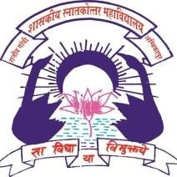

SkillDevelopment&Entrepreneurship

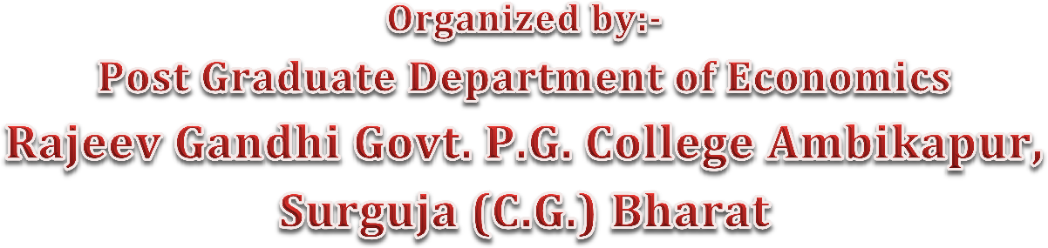

Content
Acknowledgements 3
IntroductionandProgrammeoutline 4
Openingandkeynotespeeches 9
TechnicalSession/Paneloverview 11
Summaries:mainoutcomesoftheSeminar 21
Moreinformationaanddissemination 23

Acknowledgements

As per the decision taken by the college autonomous cell for the all-round development of the students, Rs. 50,000 was sanctioned by the college for the international seminar on the proposal of the Economics Department. Also, with the registration fee of Rs. 119500 received from 217participants from India andabroad, the InternationalSeminarwhose contemporary theme was 'Skill Development, Entrepreneurship and Environment'was conducted smoothly.

In this program, researchers, teachers and students from almost all the major provinces of India including Uttar Pradesh, Madhya Pradesh, Maharashtra, Punjab, Bihar along with Ethiopia, South Africa, Nigeria, Russia, and America participated. Scholars, Professors and Researchers from almost all the big districts of Chhattisgarh thought deeply on the subject with full dedication.

WeexpressourgratitudetoallthelearnedProfessorsandResearchers.

International Seminar
SkillDevelopment,Entrepreneurshipand Environment

12& 13May 2023

Introduction
The skill development of the labour force is a priority for Indian planners. Today, everyone wants to start a successful career, so workers in the unorganised sector need to receive the right skill development training. Several plans for skill development have been released by the Indian government. They must strongly emphasise skill development initiatives and support people in using their skills and knowledge. Moreover 60% of the population in India is under the age of 25, and every year, another 28 million young people join thecountry's labour market. This gives India a distinct demographic advantage. However, demographic divided and employability from such a big workforce must be improved as just 10% of recent grads are currently employable, according to current figures. India’s GDP has been growing at a great rate of around8.2% in the last year but job creation is not catching up with it.The skill development programmes are recently getting more importance in the government's policy in India, especially in the New Education Policy 2020. There is always a shortageofskilled workforceineverysectoroftheeconomy.Theskill isdirectlyrelatedtothe labour's marginal productivity and income level. The tribal area people still lack skills which force them to come under the undeveloped region. To bring the tribes into the mainstream of development, they must be educ- ated, trained, and converted into skilled workers. Azadi Ka Amrit Mahotsav is an initiative of the Government of India to celebrate and commemorate 75 years of independence and the glorious history of its people, culture and achievements. This Mahotsav is dedicated to the people of India who have been instrumental in bringing India thus far in its evolutionary journey and hold within them the power and potential to enable honorable Prime MinisterNarendra Modi's vision ofactivatingIndia 2.0, fueledbythe spiritof Aatmanirbhar Bharat. Under the Azadi ka Amirt Mahotasv is time to introspect the skill development programme and its performance in the tribal area. At present, tribal, stand after the 75 years of independence? What is the role of microfinance institutions and integrated development programmes in the life and work of tribes? What are the main pillars of thetribal economy and ways to study the changes since independence? The term "entrepreneurship environment" refers to the numerous contexts in which large, medium- sized, small sized, and other businesses must function. Therefore, the environment has an impact on the business. Entrepreneurship is generally influenced by the environment that is produced by political, social, economic, national, and other elements. Green business owners are crucial for economic growth. Green business owners can significantly help to solve the issues of unemployment, poverty, and the environment. Compared to other businesses, green entrepreneurs play a bigger part in environmentally beneficial activities and duties. Various facets of economic development are gradually becoming very significant to development. New businesses and innovative start-ups stimulate the economy. Resources are allocated to new possibilities and market gaps to create something innovative and helpful. In order to address the new challenges & the issues of today, appropriate policies must be developed. The programme focuses on how to impart entrepreneurial development to participants using fundamental and advanced methodologies. The departments responsible for skilldevelopment and representatives of the organisations imparting training under the Pradhan Mantr Kaushal Vikaas Yojana and other schemes run by the central and state governments of

Chhattisgarh, will all have a platform to present their work during this international seminar. The Seminar will cover the actual obst-acles that many stakeholders encounter. Thus, the seminar will educate policymakers on building skill development programmes and implementingthem for businesses andenvironmentalconcerns. The seminarwithgrowon he types of skills needed by entrepreneurs for a secure and safe environment, the characteristics of young people in India, as well as their potential and ambitions. The main objective of this International Seminar is to understand the concept of Entrepreneurial Development, to understand the main components of Entrepreneurship Development; to understand the relationship between skill development and entrepreneurial development and Environment; and to know the various techniques of innovation and promoting entrepreneurial culture.

Sub-theme:-
- RoleofentrepreneursinSkilldevelopmentofyouth
- IssuesandchallengesofdevelopmentofentrepreneursinIndia

- Minorforestproduct

- NeedofentrepreneursinAgriculturaldevelopment
- Requiredskillamongthetribesintheglobalizedworld.

- NeedofCompetency-basedSkillEducationforenvironmentdevelopment

- Indigenoushealthsystemamongthe tribes

- Womenentrepreneurship;•RuralEntrepreneurship;
- Micro,SmallandMediumEnterprises;

- SelfHelpGroup (SHG)
- Socialandpoliticalenvironmentof India

- GreenDevelopmentinIndia

- EnvironmentalLaw

- CottageIndustry&Environment
- Anyothertopicrelatedwiththethemeofthe conference

ProgrammeOutline

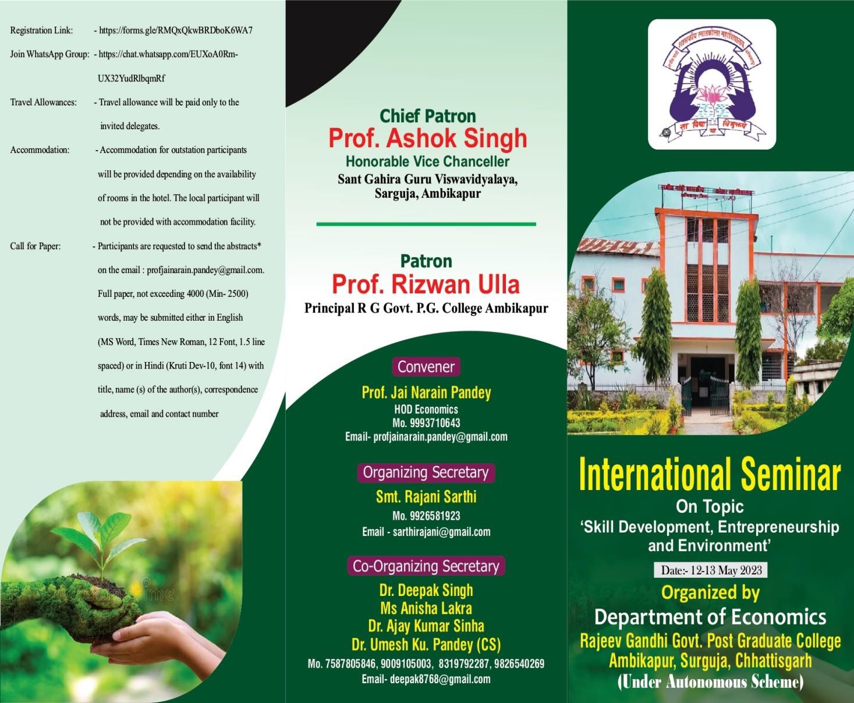


Ab.ru.1Amb,Ll,])UJ
Asmall CCJ'6U1:towninChlt.artishgaffl'sSmguja D6'ria iscalk!dAmbikapur. L1suvcsasSurguja'sDis.uiaOffice.Smgujaisuniqu,i, l(llriuabundan1forandwild.-ioim1111:i.Ncar Ambikapu,Ma.inpat (aimkno'll-na&S!MALAinChhatti:1.prh),apoJ18l;111
touristdestinatiofttNltisprimarUyfOK?stcdandhilly;thlltearea:s;ignificant!lumberofTibc:1111m1igrants.BoodhaTomplc,ULTAP;mi,
:IndMAINPAIT[GERPoi\tF:1Il.Be1111tifullocMi001:iaclOOI!D:11d:1li,Fii.hPoint,SunSaPoina,elt.Othertoorii.tOOttill:ltiontftCIII
Ambikilpur-llc:lude Rami.-Kudarprh. Dipadih.Rllbhpr,da Wai.er Fall.andTaiapani (HO(Watersprini).Most ofthe:populationeornprisutribc:1:,awlmecityhli:s;a1ilmptratcelima'ICswl apeacefuleavironmcnt.
Ab9llllh<!C•l1<'!1t'
R.:ljoovG:l,ndhi GOVClffimE!ltPot1Gr.1du:lte Colltge Ambik:lplll(C.a)W:He1-t:1bliihedii1960.It isooe of thebailCOilege ofChhM.titg:arhandsitW!ltcdinna11ualprosperityrichSu,gujllDi:1-U'iet.Thetotalaroaof the Collegeis43 :ICHS.Thecollegeh:lvc fullaudc:mic: andresea­rchorim.tcdenvi10Ament.Tlt.it:iuaito11oorn1111tcollege..InthebegiMingourColltgew.u.:afflli:lledbyPt.RaviShlnk:lrllniveJ"1:ity.
Raipurtillthe'Jf!.• 191.JaadthircallerbyGutu Gha!.iduUniversitytill200i.. Pres,m.tlyit is atlilind bySlmt GaltiraGuru Vi:sJi.-wavidy­alay:1,Arnbik:lpur. Thecollege provides:studywwlcr four fxultyAnt:, Comm.:nc, Scien.ce :1ndL:lw.

II,"111\p1,II

f•ocl'i&W..:kt.1111<.:COr111n1tk..:
- Prof.RizwanUllah.HODBotany.
- Prof.S.K.ShriV:lit:IV:1,HODPhytil!i"
- Dr.R2111e:!.hKum:a:rJaiswal,HODGeography
- DtSntb.lltllShr-i,,.-:115.lllV,HODPolitic:11Scillaco
- Dr.M11m111G1arg.HODHiMor-y
- DtRajk:lm.alMi:!.h111.HOD DqM..ofEftj'.li:!.hJt.ComrollcrAutonom-EMM
- Smt.S:1rojTi:rlcey,HODOu:mituy
- DtS.K.SiAh:1. DopanmemofChemi511y.R.ajeevGandhiP.G.CollegeAmbikilpur-
- DtA.K.Sinh:a,Deps1rnen1ofGcog,:1p11y,R.:ljoevG.-iodb.iP.G.CollegeAmbibpur
- Dr.AhhaJain.al,HOOHiOOi
- DtS.N.Pandey,Univcr:!;ity Coordil1lllllf-N.S.S.(S.G.G.VSsil.lj!II).
- Dr.PraribhaSi!Wl,HOD Dept.ofSocioDgy
- DtAK.Ciaur.HODDept.ofCornrn,uc:e

,1,1111111,""I..!Ih1_I{,I,I111111I,,,1.,.I,III,1,.JI111Illll_,1.,-..!I,1JII
l

I
  - DtGuminaTt-looy,HODDllpt.ofZoolllgy;

IclI.1IIII11I'II,I11._1.11.J.IIIIIIl.II,•ll1hlIUuI1111I
1,111,1111,1•l,111i1-.,,h"-,,.,,1i1,., ,,r,1,h1)1,

lmP41rtantl).1.<-:
n....,aflnlnllOllian..JS.,...in.-·•ll•llM""J21[)1)
L..,m....afAlro11K1S..li.,,;,ian:-AFril:Z11hllt!J

:0"1:1y1Mh2013
:•F:1wl1y.;E011{-.R.ie,,.,.-d,
Sriial•-.500{-.,SaJdmt:i-.21[)1[)f.)

C'allrg.._,A/CNa..:51[)] 004'!l114.H!ill
-lJiSC':11DfiCOOQ2141BRA.NC'H­
lrnFCl'tl•ii,BLArabik11p11L
s..s....-trn)
.I11"\I.1.-.! ,,i-..1•111,IuII'-'I,
- SliriSllftilA.K.K.erbtt:1,HODDq,t.ology.
- DtTriJMiBiswM,HODDept.ofPtyehology
- Dr.&mglllol:IPandey,HODDC!f!tofMMhemalim
- Smt.Jyori1..:11,T,a,HODAnthropolev
- ShriBaje!ihKwnar,HODDcpt.ofl..:liA·
- Shri Rajr:nKllDl.:lr.HODDep1.OfSanskrit
- ShsiCll.et:lftKwn:1r.HODComputerApplie:1tion
- Mi:!:!:MO'floi::aXen, HODCompwuSciieaclll

AJ,I""')(om11111i.:c

- DtBhupendr:1Kuma.Ethiopia.DthttTaborllniv:lity
- DtR:lvindl':IRe11:1,Soo.tll.All'ica
- Dr.SanjayRajhaiw.Ma.:co

utli11:ruSi-l.:r.-
Dr.A.D.N.BajpaiHonor:ahllllVia,Chaw::el.IlrAtalBibiBaJ:111aillnivnsi11Bilaspur
l'T-of.R..,Shankilr llononhle Vico1C1hancellor Sh:ambhv.N•hShukla UaiwBity ShahdolDr.S. K..Tripathi&Ptinc:ipaI&AdditionalDirw:torHigherEdu,c:atiun, Ambiakpu
Dr. R. N.Singh,PrincipalVYTGIM.P. G.AutonomoutColleg,ii,DurgDr.PrahlMIKumar, U11ivcni1y ofAll:1hab:ld
Pr-of.P.K.Ghosh,lfniv1nityofAllahabad
Pr-of.RilkWSinghDllpl.OfE.cO!lOmiesIGNTUAmalil..antak..
Mr.1-Libl'l!IUK.askeKti:5:1LOCIUJ'CI'DcpartmallofCivEnj'.illftrTla;DallrcTahorUnivasityEthiopiaDr.AnishGIJJl'a,Dep1 ofEconomicsUniversityofDelni, N-Delhi.

Dr. Mub:iliKumar Miema, Mohanl..:11Sukhadiy:a Uniwn:ilyUdaiplll'R.:ajll!!.th:all.Prof.R:avlldnBnhme.HOD&onomics,RniSian.larShuklaUnivo!!:ityR:aiprr­Dr.Ajell'IK.um•Sahu. Dlllfll-Of Eoolllnl.ics.,Clllltn.1Unill'en:ityOf H:11iy:a11:1
Prof.Sunil N•wadt, HOD Dqn.of Economia,Dr.BabaS:1lMil Antblldk• M:lil-.thw:lda UnivertityAv.rang:abad, M:1ha111shtr.1.Dr.BhupmdnKum:1r,Ethiopi:I.Dlllll"eT:1hor"Univcn.ity
ShriAanandAw:1:1;tlli,ShubhMo,jail::.t.P-.1.ubleAmbik.apur
Dr.YinodSm.Dept.OfEconomicslGNTUAmuk:latak-
Dr. Ravin.dr11Rena,Prof./1/onll.Wc:1.1 l.fni1,.'Cr,ity South Africa.Dr. UwvAnand. HOD B:ooomic:&. S:1p:1 Uniwrsity
Prof.B.L.SOIWlr,SchoolOfEc:on.OJ11inRaviShank•ShukbUnivw:1.i1yR.aipur
Dr.V. K..Shanna, HOD Eu)llumic:t=Govt.Bilash:aOirlP.O.CollegmBib..,-.Dr.AnitaDix.ii D.B. Oovt.P.O.Oir\5CollegeR.:liJllD
Dr.M:1nidtlOo.me., HODEconomic,CenteraJUnivcnily GGUBilHJIIII'.Prof.M.Y.M:1horeHODDllpt. ofEconomil!i"Univcrsi1yofNagpurMrs.IraRan10011,MonalisaBouriq Manendragarh.
Dr.VinodShrivllitwaP10f.&HODDr.RamManohalLohiyaA"l\':1dhV!:!.hwvidyabyaAyodhy:a.
Dr.AllUc:s.hDwivcdiAs:!.sitantProfeHOt"Political Science, G0\11... RMD Collcge Ambiuk:lpur.Dr.RohilR.:li.A:s&i5twProfl!:!.5orEc:ooornic:s. Govt.DeiJl!e c:ollq_e. Khalilab:ad..Sant Kahir
Nag:ar(U.P.)
Dr..Ani111Meshr:am.,MahinLalJainOoviemmmtColle!!'!Khum1ipar,Bhila

- DtS.K.Tripailli,FonnerPriacipaVA.D.RajeevGandhiGovt.P.O.CollegeAmbik:lpu,.
- Dr.R.N.SinghPrindralGovtVYTOovt.P.G.CoO,iigeDUJJ
- DtJyotiSinha.l'rincipalGovtR..MD.GirlsColleieAmbi::;apttr.
- Dt\uml:urn:1rMiilln,Prilcip:a\Govt.CollegeSilphUiS11111j,i111.
- DtK..L.Villhwk•ma.Priac:f)alGo"1.ScienceCollitieAmbibpur.
- Prof.S.M.P.ulhyeEx. Prof.Geography BalaudaBauirC.G.
- Prof.Vij:ayK.umarSh.-m:a,OJV1BilmaOirl!i!POColliegmBilat:ptr

- DtR.ajkilmalMi:!.hra,ControllerAutonomousE:umin.atio!I.Raj::cvGandhiP.G.CollcgeAmbibpur
- DtR.P.Singh,Coonlin:atolIruer11:1lQUllityAlilll:lllCCCllllR:ljoovGandhiP.G.CollegeAmbilc:lpttl
- Mr.LalitKumarPnd.EmploymC!ntOffiOl!rAmbi:apur.
- DtG.D.S.BagpDh:lrndha,D'II.JJC.G.
- Mr.VijayP.R.ahlngtblieHODEc:onomA.D.Colleg,eBhan.inl!i,N'agpur.

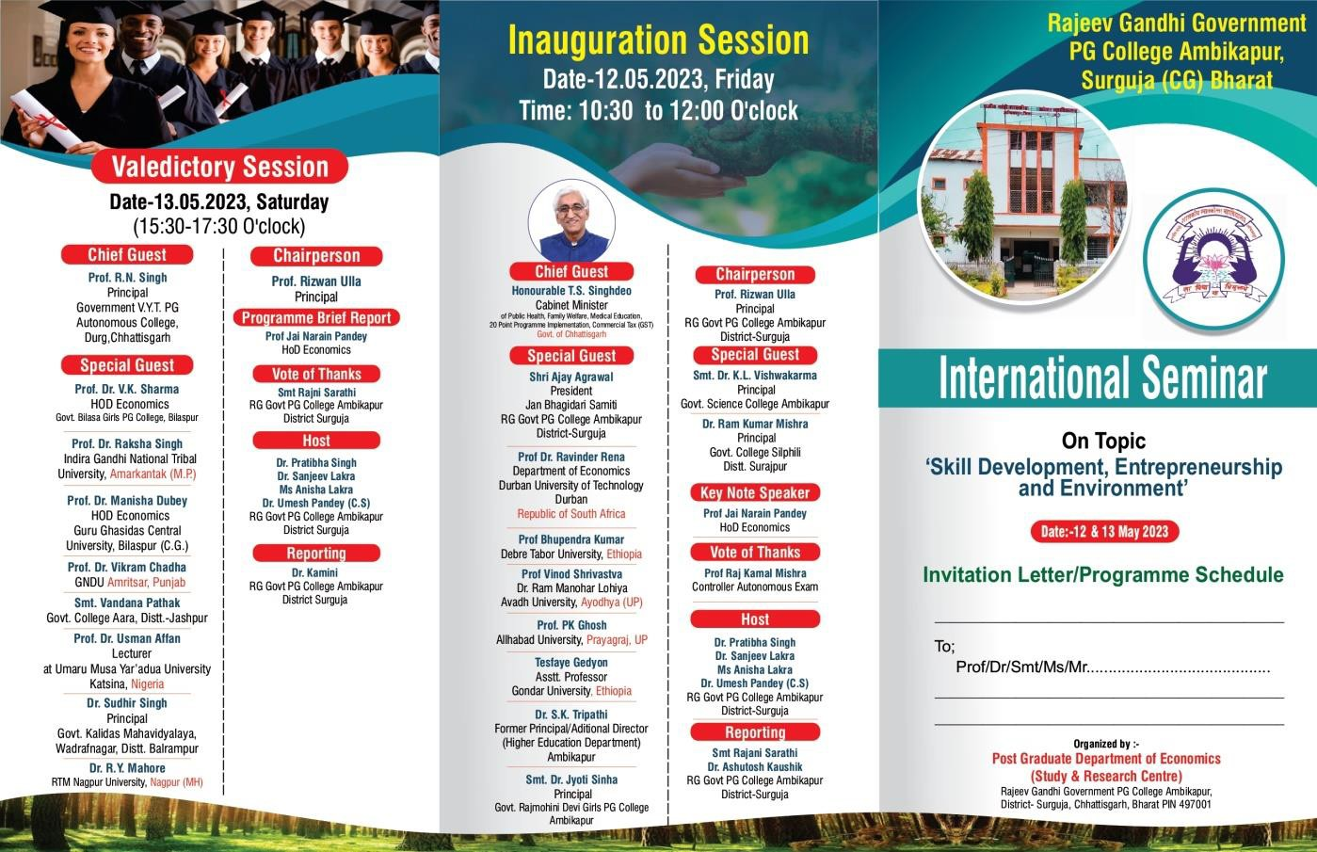
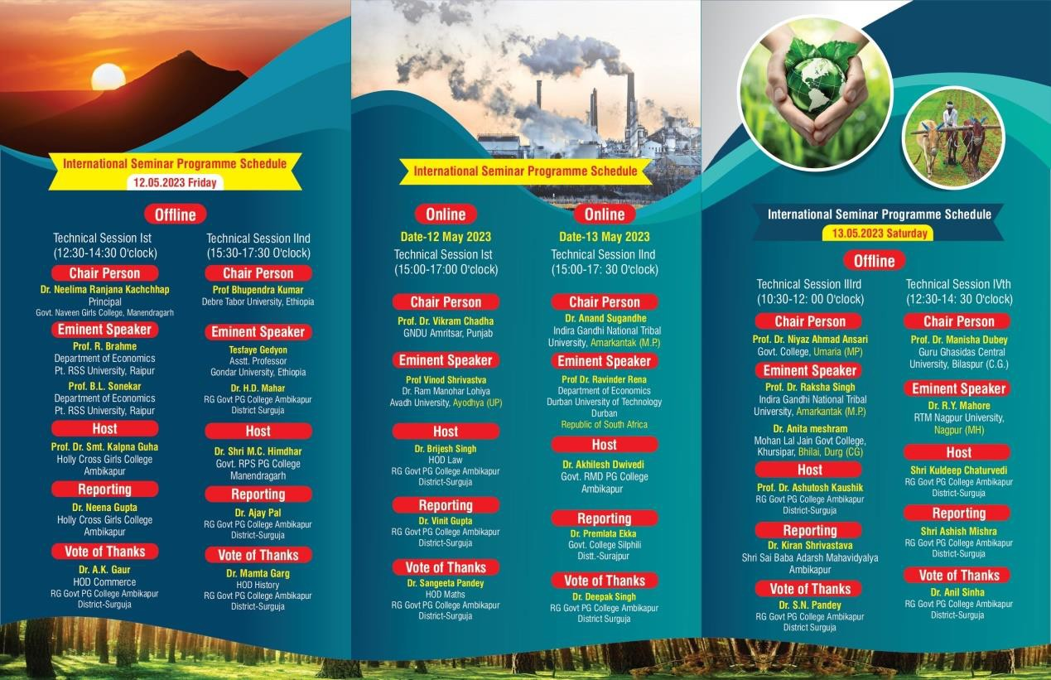

InaugurationSession
Date-12.05.2023,FridayTime:10:30to12:00O'clock

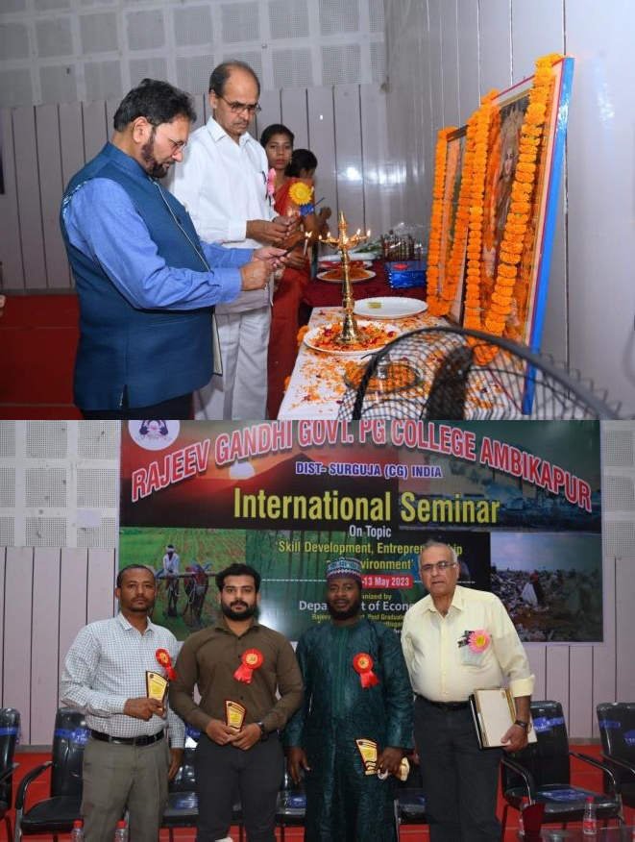
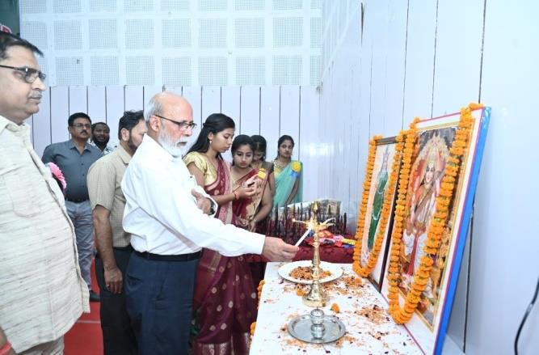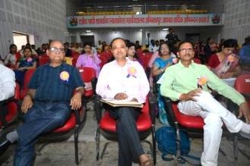

The inauguration of the program started at the scheduled time. After Saraswati Puja and welcoming of the honorable guests, the coordinator of the program, Prof. Jayanarayan Pandey, while presenting his views on the subject with welcome address, laid emphasis on giving industry status to agriculture in India and development of cottage industries. PROF. (DR.) VIKRAM CHADHA,FORMERLY,PROF&HEADPUNJABSCHOOLOFECONOMICSGND
UNIVERSITY,AMRITSAR(PUNJAB)presenteduskeynote,briefofwhichisasfollows-
“ In November 2022, India surpassed the British economy to ensconce itself as the 5th largesteconomyinthe world,with$3.17trillionGDP.Byallestimates,by2028, Indiaisprojected to position itself as the 3rd largest, with $5.16 trillion GDP, overtaking Japan and Germany. This has kindledouraspirationto becomethelargesteconomywith$45-$50trillionGDP,by2047 when India celebrates the centenary of Independence. At present India is the fastest growing economy in the world among the largest economies.

The major contributor to the perceptible growth of the Indian economy is itscomposite demographic dividend, which manifests in over 64% of the population being in the working age group of 15-64 years. But the irony is that only 4.6% of this stock has critical skills which are indispensable to provide ostensible thrust to the growth engine.
Since 2010 the focus of the policy makers has been drawn to train, skill-up and re-skill our gigantic workforce to turn it into a wealth generating asset, not only for India, but for the global economyas well. That will transform India into the economic powerhouse for the world economyby 2047.

With the launch of National Skill Development Corporation (NRDC) in 2010, and the subsequent Skill India Mission since 2015, a large number of schemes, both in the public and private sector participation mode, have been mooted. The results are encouraging as by 2022, over 12 crore workers could be skilled and trained by different agencies, including private establishments. However, the placement rate of the trained workers being low at 8%, there is a need to integrate the skilling policy with entrepreneurial development, so that the trained workers become job creators rather than job seekers. The National Policy for Skill Development and Entrepreneurship 2015 specifically aims at creating a synergy of skill formation and honing entrepreneurial capabilities to prepareinnovative techno-entrepreneurs.The innovativeskilledentrepreneurial resourcemanifests in the contemporary digital based start up economy and the innovation ecosystem that will optimise India‟s talent dividend.
The task is massive as every year over 10 crore new entrants are added to the job market who need to be trained freshly; while there are over 29 crore workers who need to be re-skilled. But once we are able to jackup the present proportion of 4.6% workers with critical skills, to 30% by2030, India is well set on course to become the economic powerhouse for the global economy by 2047

Therefore, in today's situation, economic development and environment have become complementary to each other. Environment cannot be ignored in this glamor of development. We have to preserve the environment along with the search for employment opportunities. The topic of today's international seminar is very contemporary.”

Apart from this, Dr. Bhupendra Kumar from Ethiopia and Ravinder Raina from South Africa also presented their views as online guests. Tesfaye Gedyon, who came from Ethiopia, also expressed their views. The special guest of the program was Dr. S.K. Trpathi Paying serious attention to the issue, Tripathi said that development of village industries is necessary for the development of India. Chairman of the program and Principal of the institution, Rizwan Ullah, discussed the contemporary issues and inspired the researchers from India and abroad to do excellent work. Dr. Rajkamal Mishra, Controller, Autonomous Cell expressed his thanks.

The special guest of the program, Dr. S.K. Trpathisaid that “The history of India has been golden on the strength of cottage industries and India has been a golden bird.”

Host
Dr.PratibhaSinghDr.SanjeevLakraMsAnishaLakraDr.UmeshPandey(C.S)RGGovtPG College Ambikapur District-Surguja

Reporting

SmtRajaniSarathiDr.AshutoshKaushikRGGovtPGCollegeAmbikapurDistrict-Surguja

TechnicalSessionIstDate-12.05.2023,FridayTime:12:30to14:30O'clock
Thefollowingpointswerediscussed intheTechnicalSessionIst:-
- RoleofentrepreneursinSkilldevelopmentofyouth
- IssuesandchallengesofdevelopmentofentrepreneursinIndia
- Minorforestproduct

ChairPerson
Dr.RanjanaNeelimaKachchhapPrincipalGovt.NaveenGirlsCollege, Baikunthpur
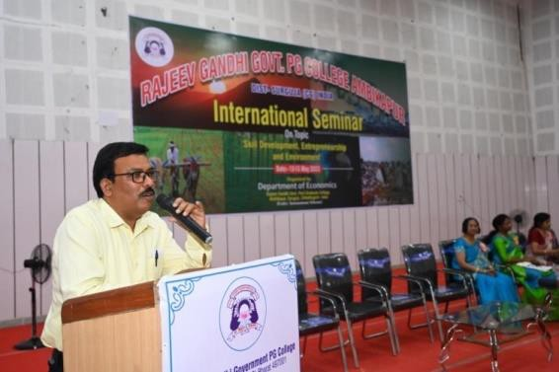
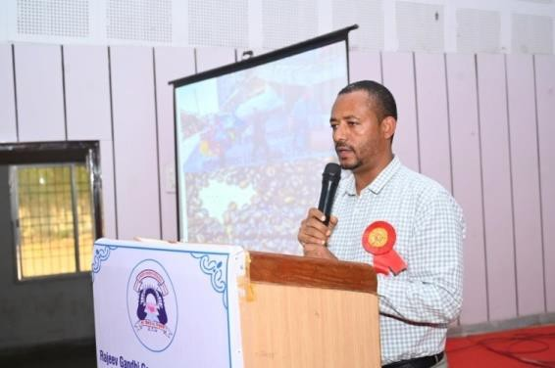

EminentSpeakerProf.TesfayeGedyonAsstt.ProfessorGondarUniversity,Ethiopia said-
Micro Small and Medium Enterprises (MSMEs) are one form of business that triggers the economic growth of manydeveloping and developed countries even to survive in an economic crisis that could occur at any time. Micro small and medium enterprises produce a variety of products to serve customers with outdated or traditional product designs since owners couldn't take formal training to improve their business and even most of the owners did it because they have taken it from their families so they will do each everything by rule thumb but there is increasing demand for theproducts since many of them are handmade products. Advertising is considered expensive and thus, Microsmalland medium enterprises can‟t affordit,though, thelackofpromotionintheenterpriseto its eventual decline and fall. As a result, adverts to the question, does advertising matter? And if yes, when, why, and how does it matter? The answers to all these questions are critically relevant because advertising in general, plays a key role both socially and economically. Most micro small andmedium enterprises naively set minimum advertising budgets considering that if they only provide excellent products or services, their image will precede them but getting new customers and establishing a new brand in an already developed market is no easy endeavor and become difficult because most of these enterprises have budget limitations. The Article is organized based on secondary sources on the title by keywords of Micro small and medium enterprises advertising and small business advertisingon the free and accessible papers bythe free personal mobile network with Panjab university network are selected based on the direct and indirect relation to the keyword. Primary kind of research is advised to deeply understand and solve the main problem of advertisingof micro small enterprises.

Dr Sushil Kumar Toppo Govt SPM College Sitapur Surguja , Mr Avinash Hota Guru Ghasidas University, Bilaspur Chhattisgarh,Dr C Toppo Govt SPM College Sitapur Surguja,Ankita Saxena Guru Ghasidas University Bilaspur Vikas Kumar Kahar Guru Ghasidas University Bilaspur, also read out his research papers.

Theysaid that:-
“Entrepreneurship is another economic component which organizes all the means of production. Accordingto ProfessorJosephSchumpeter,an entrepreneuris onewhofullyimaginesan opportunity and creates a new product, a new production method, new raw materials, new means of production and combinations. Taking advantage of new markets and opportunities by adopting In such a situation, it is important for us to know whythere is a need for women entrepreneurship. It should be known that almost half of the world's population consists of women, who are mostly uneducated,they are being exploited and exploited on a large scale. It is also necessary from the economic pointof view that this large population should get development. It should be brought into the mainstream because the criterion to judge the upliftment of man is also the upliftment of women. Women entrepreneurship can be defined as a woman or group of women starting, organizing and operating a business entity. In the development of women entrepreneurship, socio-cultural factors like family background, social values, customs, lineage, traditions, religion, ideas etc. have an important place. Women entrepreneurs are considered an important means in the economic progress of any country. Women entrepreneurs not only make themselves self-reliant but also help others. Increases employment opportunities: To encourage women entrepreneurship in Indian society, there is a needto bring changes on social, family and economic fronts.”

HostProf.Dr.Smt.KalpnaGuhaHollyCrossGirlsCollege Ambikapur
ReportingDr.NeenaGuptaHollyCrossGirlsCollegeAmbikapur
VoteofThanksDr.A.K.GaurHODCommerce RGGovtPGCollege AmbikapurDistrict-Surguja
TechnicalSessionIIndDate-12.05.2023,FridayTime:15:30to17:30O'clock

ThefollowingpointswerediscussedintheTechnicalSession IInd:-
- NeedofentrepreneursinAgriculturaldevelopment
- Requiredskillamongthetribesintheglobalizedworld.
ChairPersonProfBhupendraKumarDebreTaborUniversity, Ethiopia

EminentSpeaker
Prof.Dr.UsmanAffanLectureratUmaruMusaYar’aduaUniversityKatsina, Nigeria
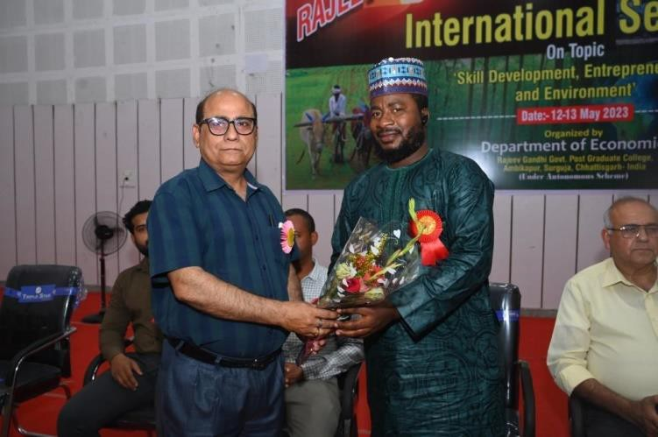
Poonam Toppo Pt JPU Govt College Patna District Korea,Ravindra Kumar Sharma GuruGhasidas UniversityBilaspur,Ms Meenakshi Sinha RG Govt PG College Ambikapur,Mr Prem Chand Yadav Sant Gahira Guru' Vishwavidyalaya Sarguja,Kavita Krishnamooti RG Govt PG College Ambikapur,also read out his research papers.

Theysaid that:-
Skills development is generally used to refer to the pro- ductive capabilities acquired through all levels of learning and training, occurring in formal, non-formal, informal and on-the-job settings. Environment can be defined as a sum total of all the living and non-living elements and their effects that influence human life. While all living or biotic elements are animals, plants, forests, fisheries, and birds, non-living or abiotic elements include water, land, sunlight, rocks, and air. When we asked about first economist then Adam Smith is named by all people. But even before Adam Smith,KautilyahadgiventheideaofeconomicsinIndia.Kautilyawroteabooktitled
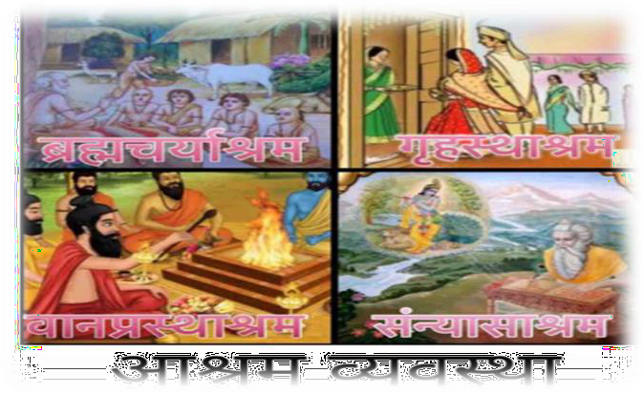
„Arthshastram„inSanskrit,expressinghiseconomicideas.Kautilyahasusedthe scriptures,Purano,UpanishadoaswellasthewritingsofManu,Shukracharya,Yagnavalkyaetc.in hisbook. IntheeconomicsofKautilyahedoesnotstudythewealthofnations,nordiscussesitsnature and causes. But he gives such advice to the king. That the power or wealth of the State should be as well as maintain and increased. Thus, the economics given by Kautilya is not „pure and complete economics‟.
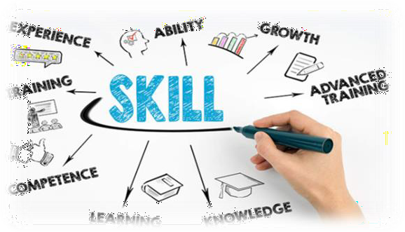

Atthetopofthecastesystem
aretheBrahmins,whotraditionallywerethepriestsandscholars.Theywereconsideredtobethe mostspirituallypureandwereresponsibleforperformingreligiousceremoniesandteachingthe sacred texts. Below the Brahmins were the Kshatriyas, who were the warriors and rulers. They were responsible for protecting society and enforcing the law. Next in the hierarchy were the Vaishyas,who were the merchants and traders. They were responsible for commerce and trade, and also formanaging the economy. At the bottom of the caste system were the Shudras, who were the laborers and peasants. They were responsible for manual labor and were considered to be the lowest caste. “INDIAWASALWAYSMEANTTOBEALANDOFSKILLEDWORKFORCEBUTITWASMADE JUST AN AGRICULTURAL LAND DUE TO THE BRITISH PLEASURE.”

HostDr.ShriM.C.HimdharGovt.RPSPGCollegeBaikunthpur

ReportingAjayPalRGGovtPGCollegeAmbikapurDistrict-Surguja
VoteofThanksDr.MamtaGargHODHistoryRGGovtPGCollege AmbikapurDistrict-Surguja

TechnicalSessionIIIrdDate-13.05.2023,SaturdayTime:10:30to12:00O'clock

ThefollowingpointswerediscussedintheTechnicalSessionTechnicalSessionIIIrd:-
- NeedofCompetency-basedSkillEducationforenvironmentdevelopment
- Indigenoushealthsystemamongthe tribes
- Womenentrepreneurship;•RuralEntrepreneurship;

ChairPerson
Prof.Dr.NiyazAhmadAnsariGovt.College,Umaria(MP)
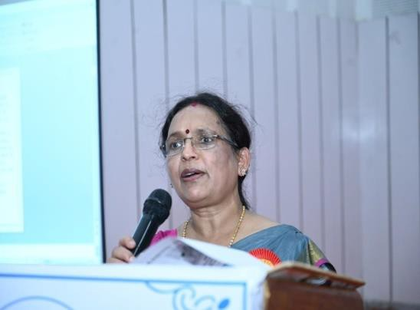
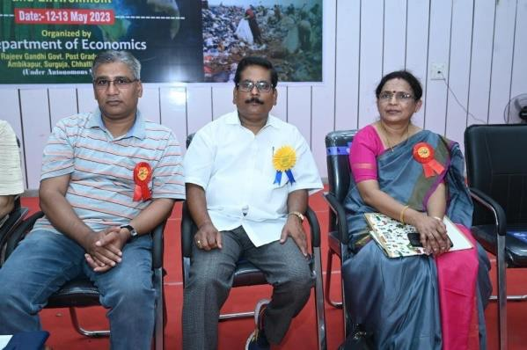

EminentSpeakerDr.Anita MeshramMohanLalJainGovtCollege,Khursipar,Bhilai,Durg(CG) She Said:-
Economic environment has great importance in entrepreneurship development. The success of any business mainly depends on the economic environment. The contribution of economic environment to entrepreneurship development is as follows
- Industrialpoliciesinour countryareannouncedbythe governmentwhich explainsthepolicies of the government announced for the development of industries.
- The government has permitted foreign direct investment for all industries except a small negative list under the foreign policy. As a resultindustries are developing.
- In order to strengthen the capital market for the development of industries, several fiscal incentives havebeen announced from timeto timebytheCentral Government underits budget announced every year, which also helps entrepreneurs in raising capital.
- The license system has been adopted by the government under the industrial policies for industrial development, through which the government is controlling the increase in the capacity of setting up new industries.
- Entrepreneurs or adventurers are part of a society. The environment or environment in which the entrepreneur lives, he has to establish his business in the same and his business is affected by the environment. Along with this, the entrepreneur shall haveto find opportunities for himself in this environment. Therefore, environmental information is important for the entrepreneur. Its importance can be explained in the following ways.
  - InSearchingfor Opportunities
  - in survival
  - Inachievingsuccess
  - Self-adjustment
  - Protectionof environment
If the social and economic environment is good and pleasant, then the working efficiency of the entrepreneur increases. The feeling of social togetherness develops economic and mentaldevelopment. Similarly, eveniftheweatheris favorable,theworkefficiencyincreases. If seen, in UP, Bihar etc. summer, rain, and winter etc. every season goes to its intensity, as a result after atime it becomes difficult to work, walk on the road, go out in the open In today's summer. Man keeps waitingfor theweathertobefavorable.Ifitrainstoomuch, the floodturnswaterontheearth.Human

beings,societyand natureall cooperatein development.
The sum total of the physical and cultural conditions that surround human beings and affect them is called 'Environment'. There has been an unbreakable relationship between man and nature since the beginningoftime.Naturehasplayedanimportantroleinthedevelopmentofcivilization. Intheinitial stage of development, any living being or human first tries to adapt with the nature, after that it graduallytries to change nature.Butinthis course of its development, the increasingmaterialistic ambitions of man have brought about so much change in the environment that the balance between man and nature, which is the basis of life on earth, has reached the verge of collapse. At the sametime, the short-sighted development processes of human beings have taken a destructive form. It was realized in thedecadeof 1970s that thepresent trend ofdevelopment is unbalancedand thereaction of environment can convert it into destructive development.
The United Nations expressed serious concern over environmental imbalance in a May 1969 report, 'For the first time in the historyof mankind, a worldwide crisis of environmental imbalance is arising. Unlimited increase in human population, capable of environmental needs and danger of increasing development of plant life – all these are its symptoms. If this current trend continues then life on earth may be in danger.

Ajay Guru Ghasidas Vishwavidyalaya Bilaspur, Ankit Kumar Pandey Mahatma Gandhi Antarrashtriy Hindi Vishwavidyalaya Wardha,Jasmin Bhesra Guru Ghadidas Central Bilaspur,Ankita Pandey Guru Ghadidas Central Bilaspur, Dr GDS Bagga Govt College Dhamdha, Kalyani Meher Guru Ghadidas Central Bilaspur, also read out his research papers.

Theysaid that:-
Nanaji Deshmukh considers the raw materials provided by natural sources to be the most important for rural entrepreneurship. He has considered agriculture, forest, geological and animaloriginasthe main sourcesofrawmaterials.Theprocessbywhich rawmaterialsareconverted into human useful items is called industry and the process through which raw materials are transformed and prepared for use is called technology.Nanaji Deshmukh defines rural entrepreneurship based on indigenous knowledge as an enterprise built from natural resources using industry and technology, without harming nature, and keeping in mind the needs of the next generation while fulfilling one's own needs and maintaining sustainability. Let's see.The same ideaof fulfilling human needs without disrupting the supply of natural resources is prevalent in hisconcept of rural entrepreneurship and he has also presented successful examples of the same through various experiments. Therefore, there is a great need of today to consider the indigenous knowledge based rural entrepreneurship concept and applications.

Host Prof. Dr. Ashutosh Kaushik RG Govt PG College Ambikapur District-Surguj ReportingDr.KiranShrivastavaShriSaiBabaAdarshMahavidyalyaAmbikapur Vote of Thanks Dr. S.N. Pandey RG Govt PG College Ambikapur District Surguja

TechnicalSessionIVth(12:30-14:30O'clock)Date-13.05.2023,SaturdayTime: 12:30 to 14:30 O'clock

Thefollowingpointswerediscussedinthe TechnicalSessionTechnicalSessionIVth:-
- Micro,SmallandMediumEnterprises;
- SelfHelpGroup (SHG)

ChairPerson

Prof.R.N.SinghPrincipalGovernmentV.Y.T.PGAutonomousCollege, Durg,Chhattisgarh
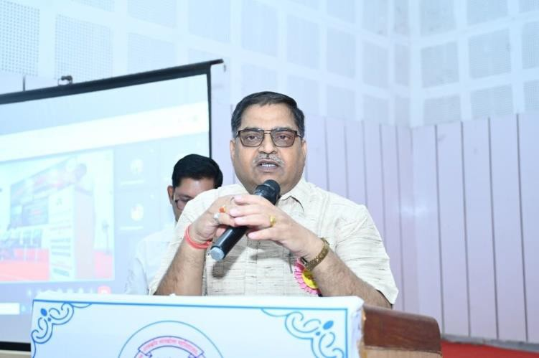

EminentSpeaker
Dr.R.Y.MahoreRTMNagpurUniversity,Nagpur(MH)

He Said

A daily increase in the demand for organic products reflects people'spsychological inclination toward wholesome foods free of pesticides, dangerous chemicals, and fertilizers. The MSME sector supports organic farming in order to meet the rising demand for food free of chemicals. The MSME sector role begins with offering appropriate training and marketing support so that farmers can easily practice organic farming under the proper direction.

Madhavi Jaiswal Guru Ghadidas Central Bilaspur, Mamta Vishwakarma Guru Ghadidas Central Bilaspur, Ram Avatar Singh Guru Ghadidas Central Bilaspur, Aslam Khan Govt Kamla Nehru Mahila Mahavidyalaya Damoh MP, Chandan Saroj Mahatma Gandhi Antarrashtriy Hindi Vishwavidyalaya Wardha , also read out his research papers.

Theysaid that:-
Harratikrais asmall villagesituatedon thesouth ofblocksurajpurof chhattisgarhstate near rihand river. The population of this small village is approx 5000, many different types of people settled there. People of the village grow vegetables and do farming for their survival. People of the village are very hardworking and entrepreneur as they work on their own for money and life.The villagers farm rice two times annually.The land of the village is plateau and the villagers grow many vegetables in summer season and sell these vegetables in surajpur, bishrampur and nearly market places This way the people of Harratikra spend their life.
In the village there is many SHG groups which helps the villagers to think beyond and for entrepreneurship and helps in earning for them. Many SHG group has become helpful in small villages to grow and for the people to come front of the world There aretotal 15 SHG group in village which are working there fields and providing opportunities for the villagers.
There are15 groupsLakshmi group , Annapurna group , Radha group , Saraswati group , Maa Mahamaya group , Shiv group , Santoshi group , Tara group , Sai group , Lakshamii group,Jaimaaadishaktigroup,Paridhigroup,Durgagroup,Hariomgroup,SaksharBharatgroup
. These areSHG groups in harratikra village which works in different field such as Grocery distribution , poultry farm ,hygiene field ,compost manure production,bari development , madhyan bhojanand many more.These groups teaches many skills to people which helps them financially.
These SHG group has contributed in development of the village and helped the village financially.SHGareoneoffastgrowingsmallorganizationsthatarechanginglifeofthousandsand

empowering women as well providing jobs for people .SHG helps people in learning new skills as poultry farming, mushroom cultivation , compost manure production and many more skills
Micro, small and medium industries have an important contribution in the Indian economy. Itis the backbone of the Indian economy. It creates employment opportunities and plays an important role in the development of backward and rural areas. Today it is also moving towards realizing the dreams of 'Made for World' of self-reliant India. It contributes about 29% to the country's domestic product. There are about 6.3 crore dadams in India and it is a source of livelihood for about 12 crore people. After China, India has the largest dam base in the world. The sector provides a wide range of services and is engaged in manufacturing more than 6000 products. Its share is 40% in the export market and 45% in the manufacturing sector. Atpresent, the government has special focus on this sector to fulfill the objective of 5 trillion economy. Finance Minister Nirmala Sitharaman had announced in 2020 that the government will guarantee loans up to Rs 3 lakh crore for this sector. This is likely to benefit 45 lakh Dedham industries. It has also been linked to e-market.

Therefore, if the above mentioned challenges and problems are resolved, then MSMEs will actually be able to help in creating a Rs. 5 trillion economy and a self-reliant India in the coming times. (DADM) will play an important role and the dream of 'Vocal for Local' and 'Vocal for Global' will be realized.

Host
ShriKuldeepChaturvediRGGovtPGCollegeAmbikapurDistrict-Surguja

Reporting
ShriAshishMishraRGGovtPGCollegeAmbikapurDistrict-Surguja

VoteofThanks

Dr.AnilSinhaRGGovtPGCollegeAmbikapurDistrict-Surguja
OnlineTechnicalSessionIst(15:00-17:00O'clock)Date-12May 2023

Thefollowingpointswerediscussedinthe ‘TechnicalSessionOnlineTechnicalSessionInd’:-

- Socialandpoliticalenvironmentof India
- GreenDevelopmentinIndia

ChairPerson
ProfDr.RavinderRenaDepartmentofEconomicsDurbanUniversityofTechnologyDurban Republic of South Africa , also read out his research papers.

Theysaid that:-
India is one of the fastest growing economies and now become the world‟s most populous nation according to United Nations population fund report. In terms of purchasing power parity India is the third largest and in account of GDP fifth largest economy in the world. Similarly, India is also lagging in many indicators in the world. There is need to focused need-based practical approachable policies to achieve sustainable development. Green economy is one of the important aspects of it. The concept of green economy has been gaining momentum all over the world. India is no exception. The central government of India has presented the budget for the year 2023-24 and green growth has been described as the first priority of this budget.
At a time when the eyes of the whole world are on India‟s economy, making green developmentapriorityreflectsIndia‟scommitmenttodevelopmentaswellassensitivityand

responsibility towards the environment. In these aspects green entrepreneurs help to provide the hotbed for starting and sustaining a green economy by providing green products and services.
A green economy is defined as low carbon, resource efficient and socially inclusive. The current paper seeks to discuss the concept of green economy, its need for green growth and sustainable development, challenges ahead and the benefits that will accrue to the world.
Keywords:greeneconomy,greengrowth, entrepreneurship.

EminentSpeakerProfVinodShrivastvaDr.RamManoharLohiyaAvadhUniversity,Ayodhya(UP)

Dr Sharda Nand Sahani R S College Muzaffarpur,Mr Lokesh Khawale The Bhopal School of Social Science Bhopal,Mr Brij Kishore Ram Shri Narayan Singh College Motihari,Dr SmtSanjuPandeyGovernmentNKCollegeKotaBilaspur, RaviKumarNalandaOpenUniversity, Shubham Raj Magadh University Bodh Gaya Bihar, also read out his research paper
TheySaythat:-
The global economy cannot function without agriculture, which is also crucial to the economic growth and development of nations all over the world. Agriculture has a substantial economic contribution, but it still faces several difficulties, such as limited access to advanced technologies, poor infrastructure, and insufficient funding. In manynations, these difficulties have led to low productivity, decreased earnings, and food insecurity. This study examines how entrepreneurs contribute to agricultural development and emphasises the necessity of their involvement in the industry.
According to the report, entrepreneurs play an important role in agricultural growth by delivering innovative solutions to the sector‟s issues, creating jobs, and raising production. Their participation in agriculture, however, necessitates a favourable governmental and regulatory environment, enough financial support, and access to contemporary technologies. The study suggests that governments establish policies and tactics that stimulate agricultural entrepreneurship in order to achieve long-term economic growth and development.

HostDr.BrijeshSinghHODLawRGGovtPGCollegeAmbikapurDistrict-Surguja
ReportingDr.VinitGuptaRGGovtPGCollegeAmbikapurDistrict-Surguja

VoteofThanksDr.SangeetaPandeyHODMathsRGGovtPGCollegeAmbikapurDistrict- Surguja
OnlineTechnicalSessionIInd(15:00-17:30O'clock)Date-13May 2023

Thefollowingpointswerediscussedinthe TechnicalSessionOnlineTechnicalSessionIInd:-
- EnvironmentalLaw
- CottageIndustry&Environment

ChairPerson

Prof.Dr.VikramChadhaGNDUAmritsar,Punjab

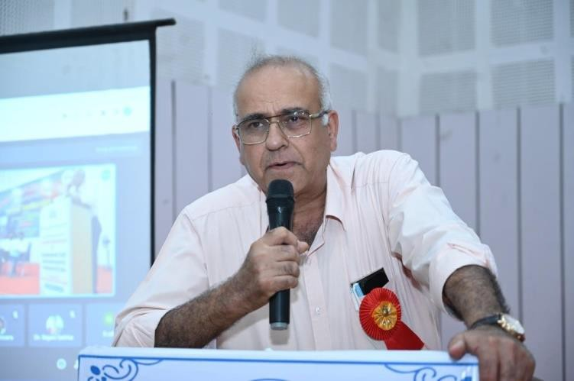

Kishore Kumar Kothari Govt Model Residential Girls College Narayanpur, Madhvi Bapurao Dhurve Mahatma Gandhi Antarrashtriy Hindi Vishwavidyalaya Wardha,Diksha Dixit Barkutullah University Bhopal,Shabana Momin Guru Ghadidas Central Bilaspur, Dr Bhawna Abhishek Pradhan Govt College Pendra , also read out his research papers.

Theysaid that:-
In today‟s globalized era, Skill development is the basic necessity for self- employment and entrepreneurship. Indeed, it is the need of the hour for the economic development of 21st Century India. Today, every child must be imparted vocational education as a part of the curriculum. Education is the proper tool through which skill development is possible. It can make the all-round development of the individual. Vocational classes should be imparted as a part of the curriculum. By doing so, the cost of skill development can be reduced. Moreover, children can learn fast than the more grown up adults. When these children become adults, they can earn their own livelihood. They can learn the value of money and the taste of earning by their own sweat and brow. Besides, these children can learn some basic marketing strategies. It should be done under the supervision of a teacher. Schools should be established and the existing schools should be remodeled as sort of industrial schools. Here, industrial school refers to a school where both academic and vocation education are given. It best suits for the residential schools. However, it can be adjusted and practiced with other schools too. The present paper demonstrates the need and importance of skill development. It also focuses on the different aspects such as skills, necessityof skill development, life skills which helps to get employability. Key Words: Skills, Skill development, Importance of Life Skills, self-employment, entrepreneurship etc.

EminentSpeaker
Prof Dr. Ravinder Rena Department of Economics Durban University of Technology Durban Republic of South Africa

HostDr.AkhileshDwivediGovt.RMDPGCollege Ambikapur
ReportingDr.PremlataEkkaGovt.CollegeSilphiliDistt.-Surajpur

VoteofThanksDr.DeepakSinghRGGovtPGCollegeAmbikapurDistrict Surguja

ValedictorySessionDate-13.05.2023,Saturday(15:30-17:30O'clock)

ChiefGuest
Prof. R.N. Singh Principal Government V.Y.T. PG Autonomous College, Durg,Chhattisgarh Highlighting the usefulness of the program, Dr. Singh emphasized onthe scheme
basedgram budget.
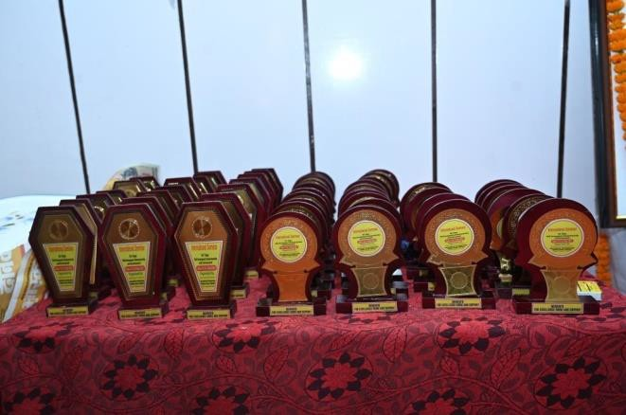
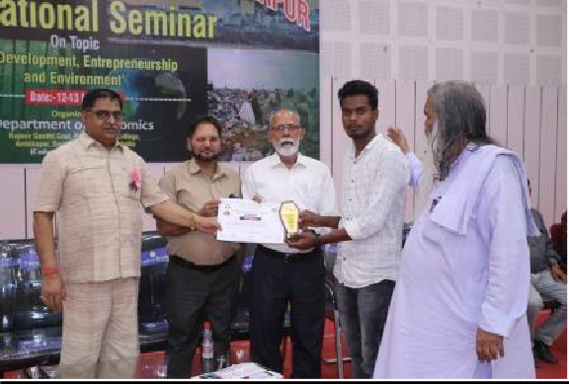

SpecialGuest
Dr. S.K. Tripathi Former Principal/Aditional Director (Higher Education Department) Ambikapur & Dr. Anita meshram Mohan Lal Jain Govt College, Khursipar, Bhilai, Durg (CG)

Chairperson
Prof.RizwanUllaPrincipalSaidthat,“thethoughtsoftheparticipantsintheprogramwill definitely enhance development oriented knowledge for the society and the nation.”

ProgrammeBriefReport
Prof Jai Narain Pandey HoD Economics, told that 217 participants participated in 04 offline and 02 online sessions and 97 research papers were read by researchers.

VoteofThanks
SmtRajniSarathiRGGovtPGCollegeAmbikapurDistrict Surguja

Host
Dr.PratibhaSingh,Dr.SanjeevLakra,MsAnishaLakra,Dr.UmeshPandey(C.S),RGGovtPG College Ambikapur District Surguja

Reporting
Dr.KaminiRGGovtPGCollegeAmbikapurDistrict Surguja
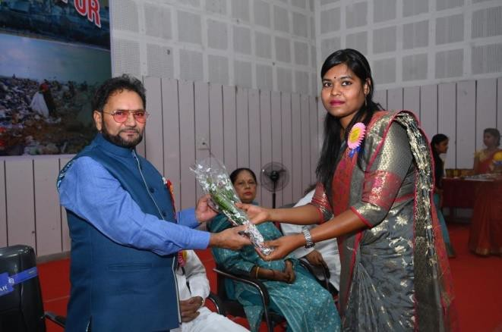
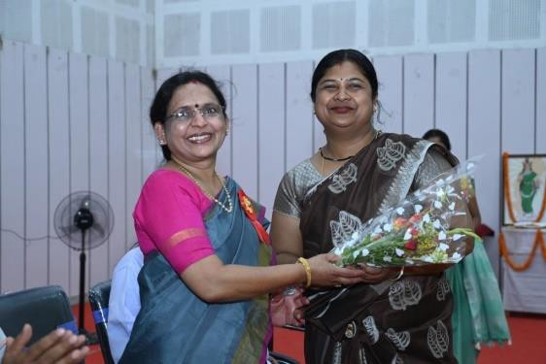

Summary

Skills, enterprise and environment complement each other. Human life is the path to highest welfare. The needs of humans are limited, those of demons are unlimited, those of gods are less and those of God are zero.

In the Ashram system of Indian culture, there is a provision of Gyan Yoga, Karma Yoga, Daan and Yagya in Brahmacharya, Grihastha, Vanaprastha and Sanyas respectively.

Thevalueoflifehasbeenbasedonbiodiversity.Wehavealwaysgivenpriorityto
business.

Fortheprotection and all-rounddevelopment ofhumanity, wewill haveto travel to the forest, society and forest and move forward in the direction of spiritual socialism by preserving the environment.

Our intention behind the seminar organized on the topic “Skill Development, Entrepreneurship and Environment” was to structure innovative principles through ideological thinking to restore the glory of the ancient times.

Thefollowingfactscametolightinvarioustechnicalsessionsoftheinternationalseminar-

  - India has been ideologicallystrongsinceancient times.

  - Indiahasbeenarepresentativeofglobalideology.TheaimofIndiawas“Vasudhaiva Kutumbakam”.

  - Indiahasalwaysbeen aleaderinskilldevelopment.

  - India'scastesystemhasbeenbasedon skill.

  - Theenvironment canbepreservedonlybyliving withnature.

  - Coordinationof spiritualityandsocietyisnecessaryforinnovation.

  - Developmentofentrepreneurshipispossibleonlythroughinnovations.

  - Conservationofbiodiversitywas the mainfocusof theAshram system.

  - Liberalization,PrivatizationandGlobalization(LPG)areveryharmfulforcottageenterprises.

  - Themain reason for globaldeclineis over-consumption and exploitation.

Ultimately we can say that purity of water, air and food is possible only through conservation of biodiversity. Pure thoughts arise only from pure food. Pure ideas will lead to development of innovation and entrepreneurship.

SomePhotoofProgramme
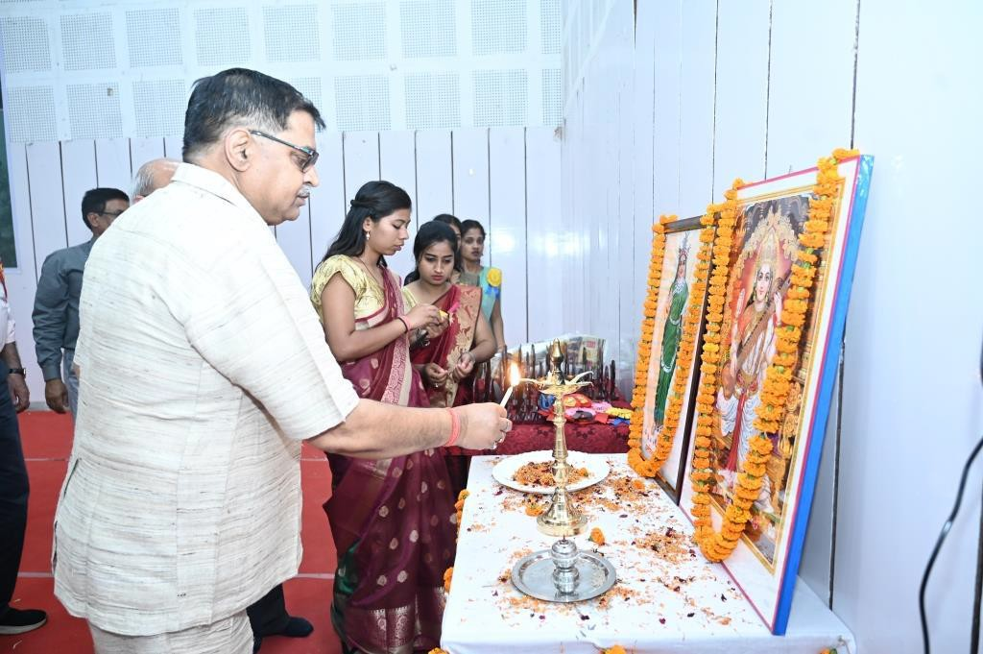

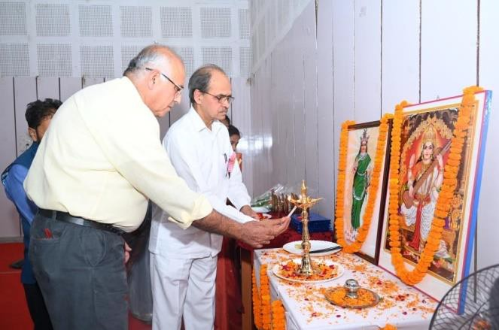
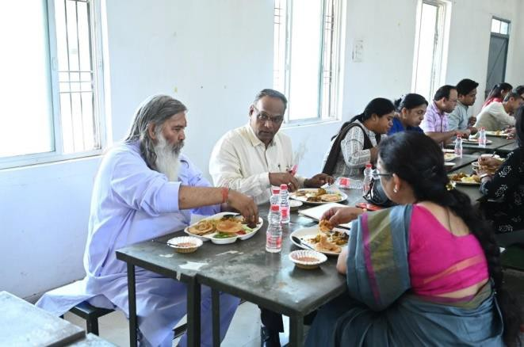

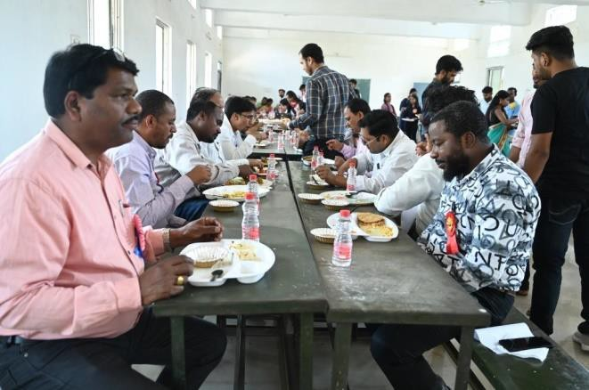
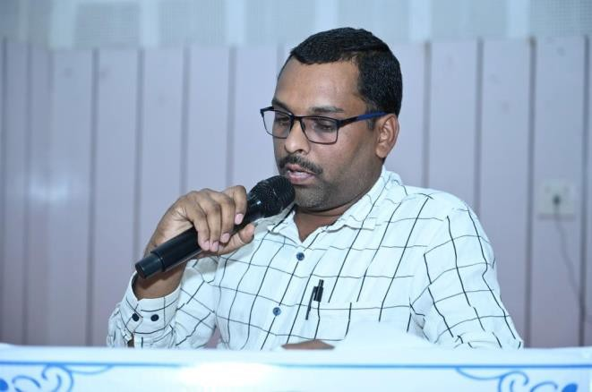

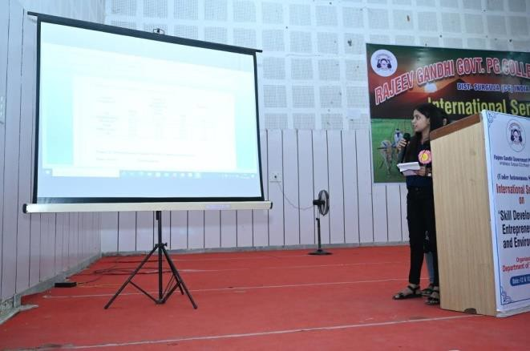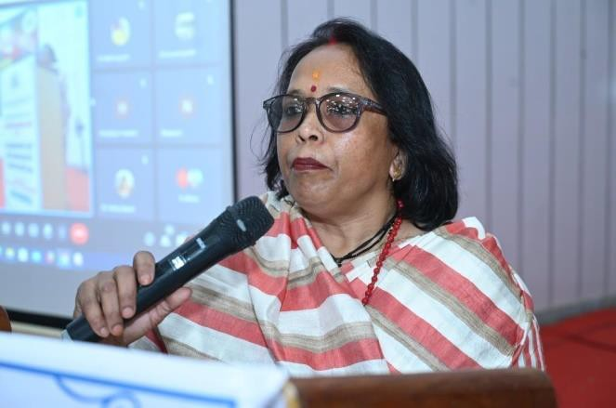
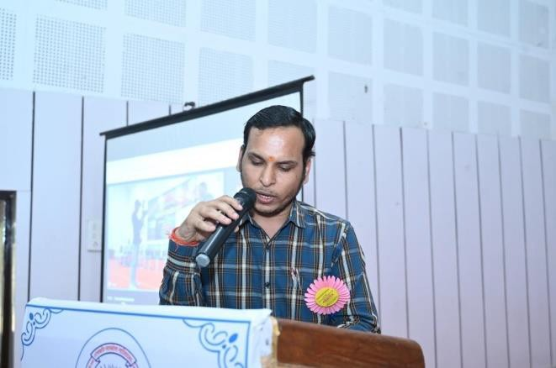
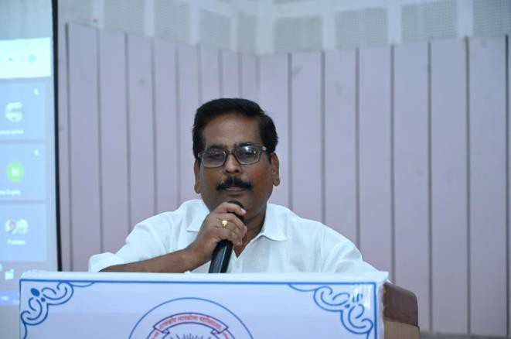
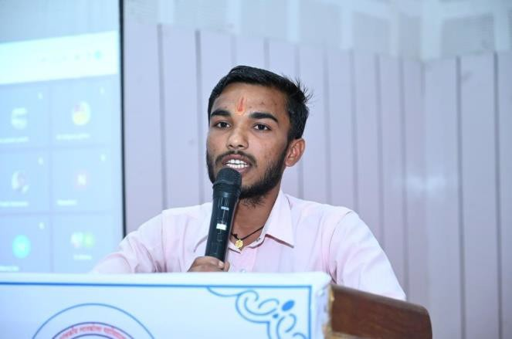
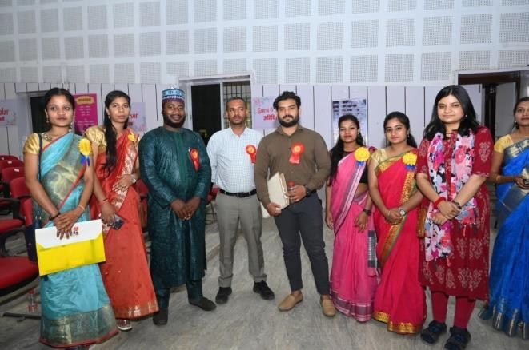
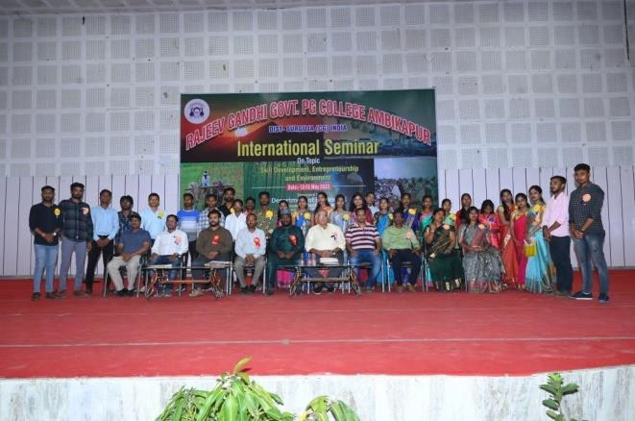
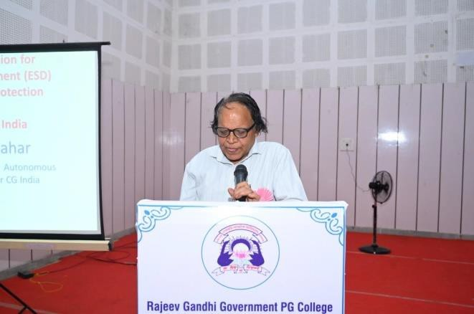

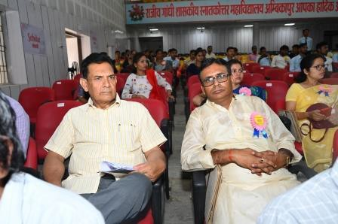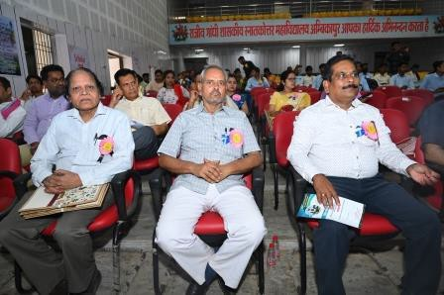
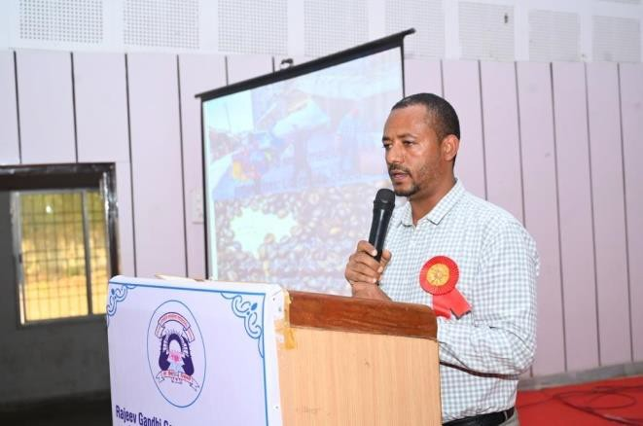
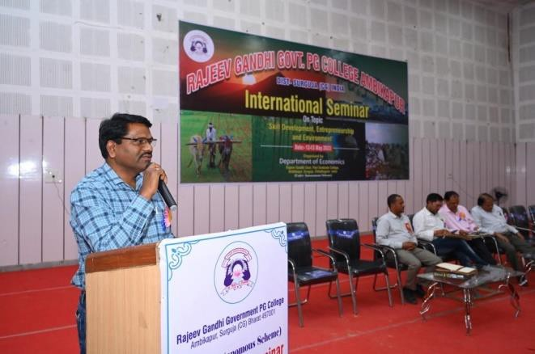
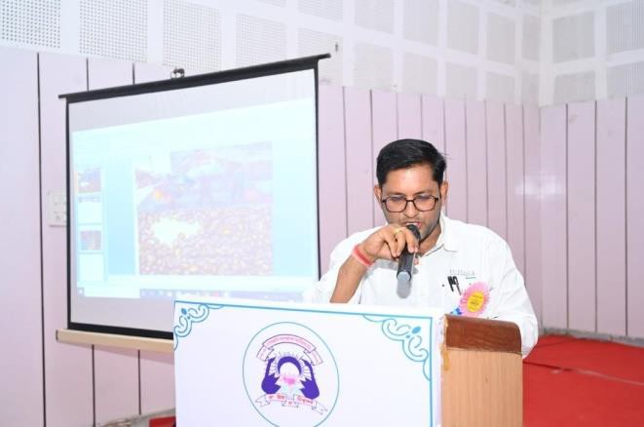
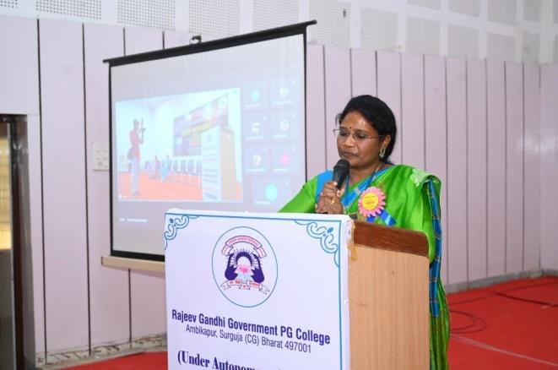
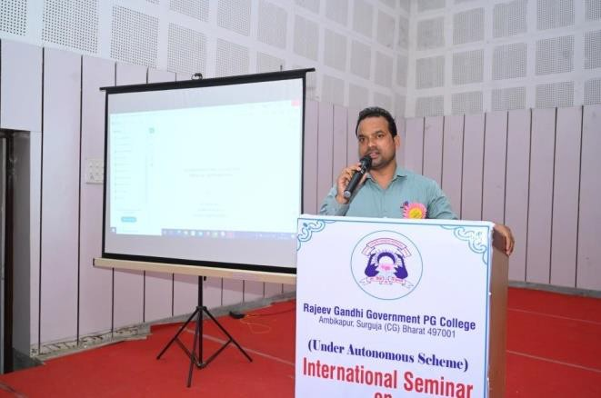
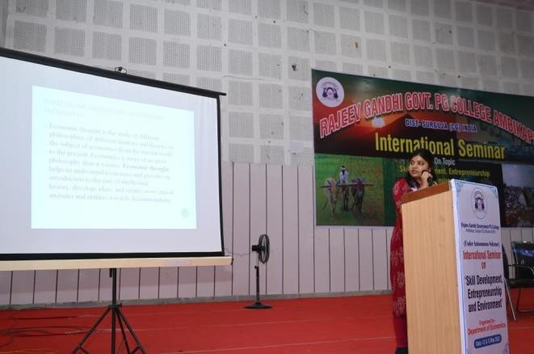

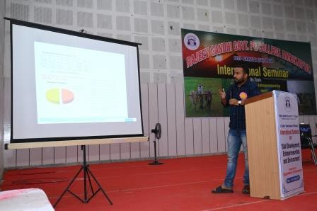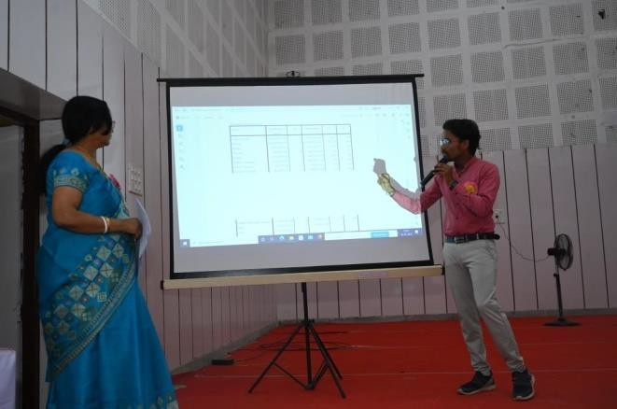
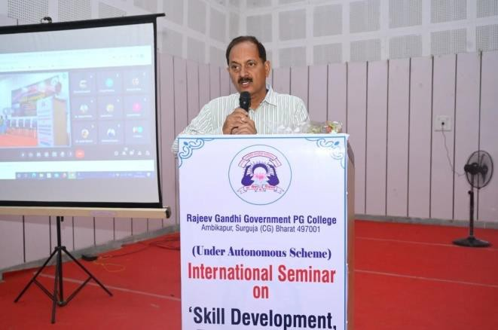
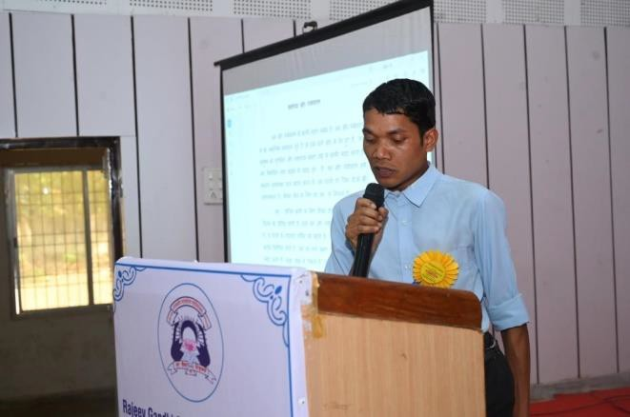
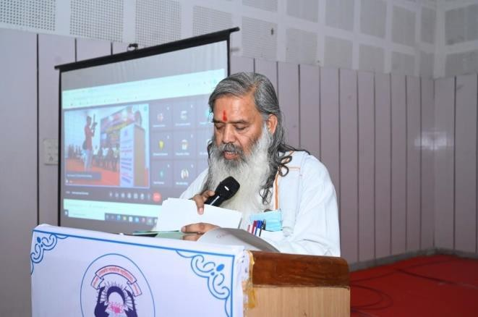
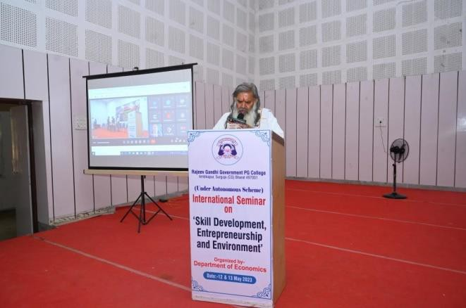
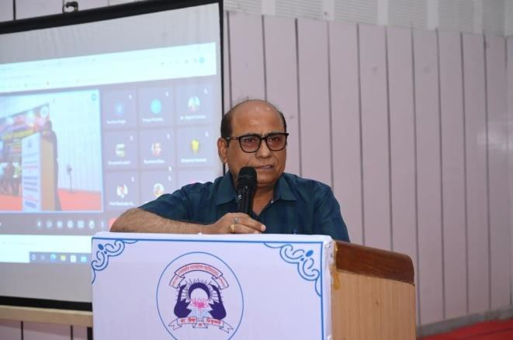
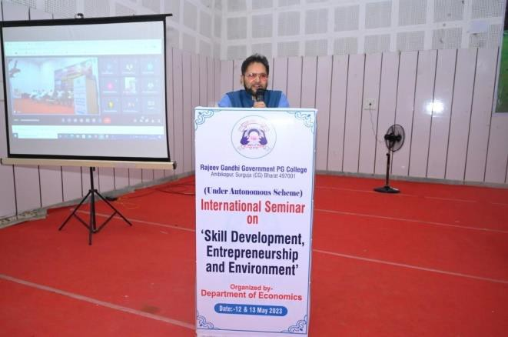

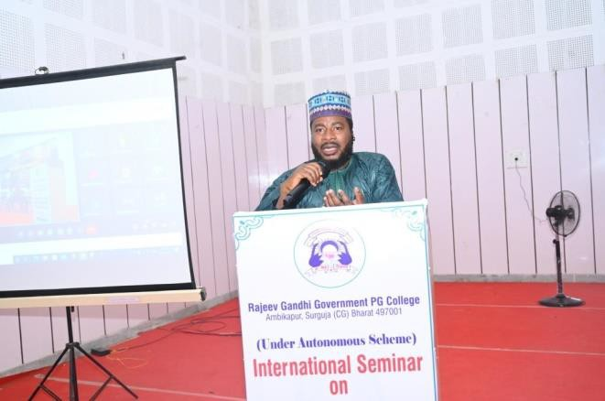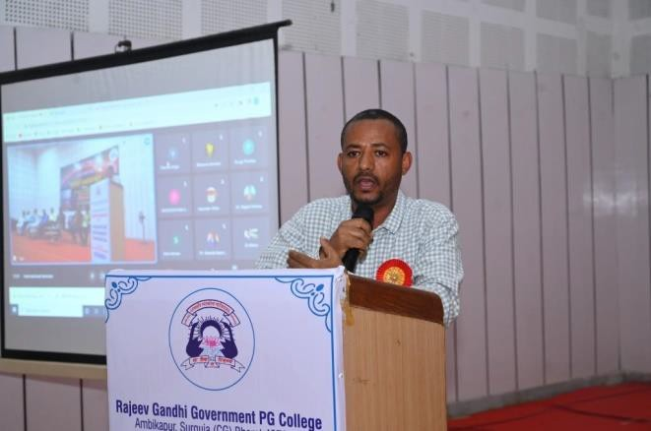

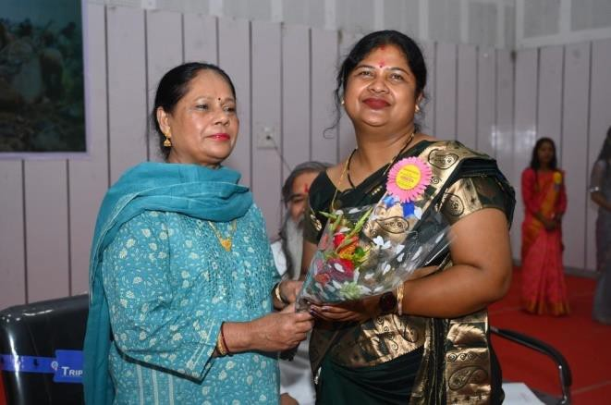
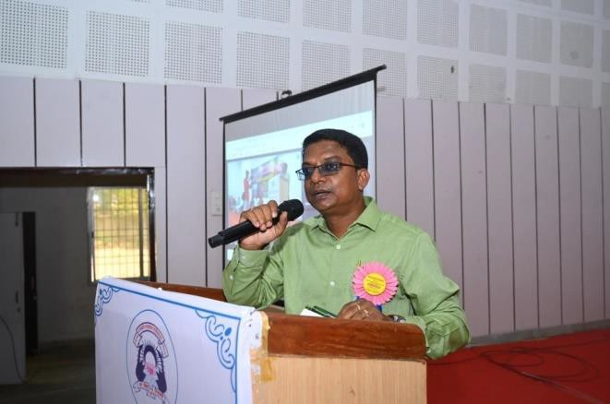

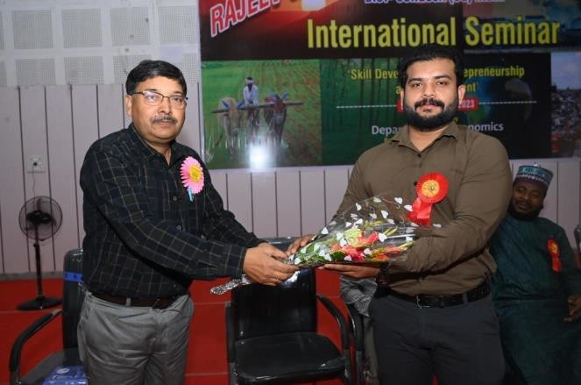
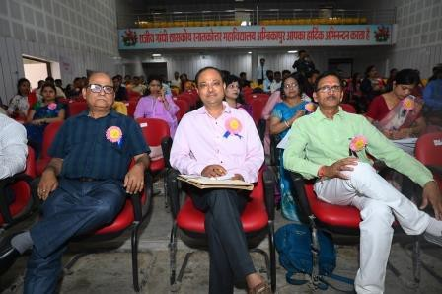

ProgrammeRelatedNews
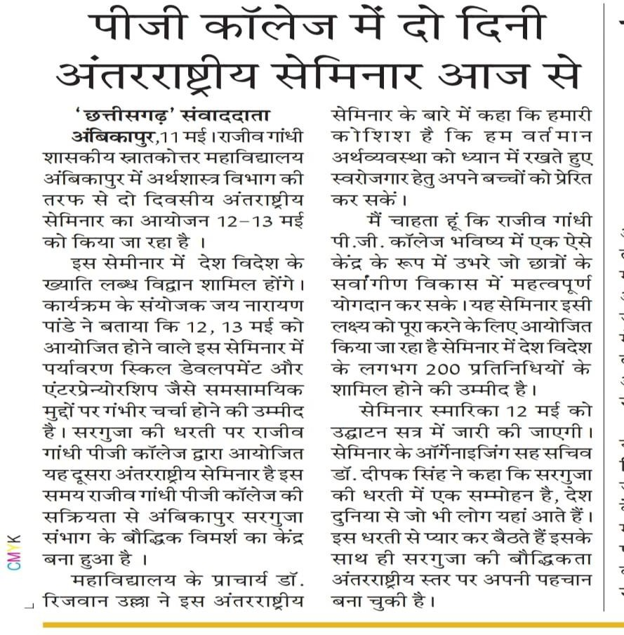

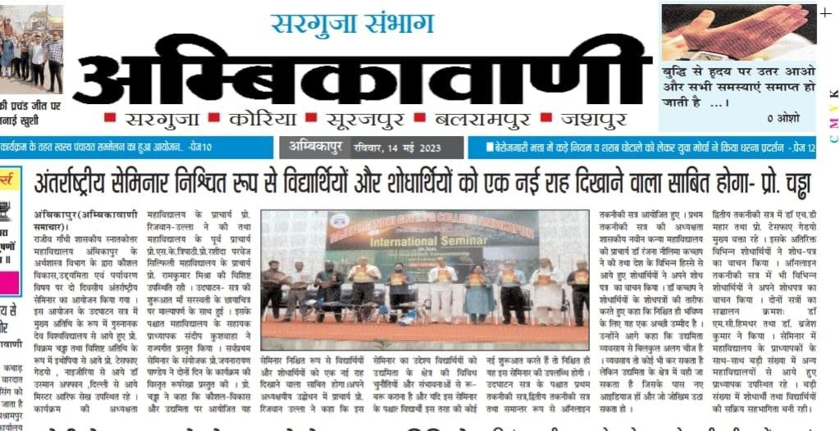

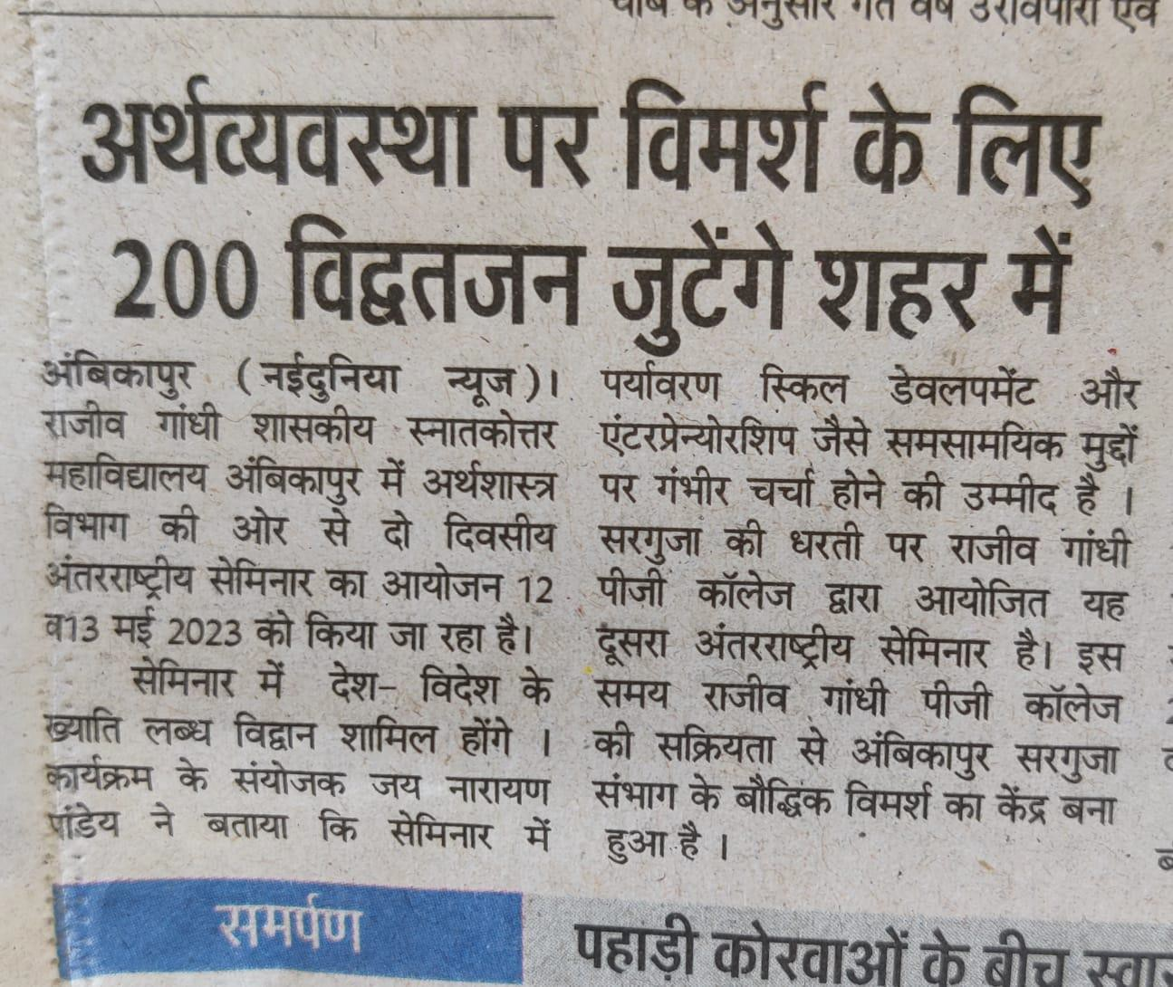
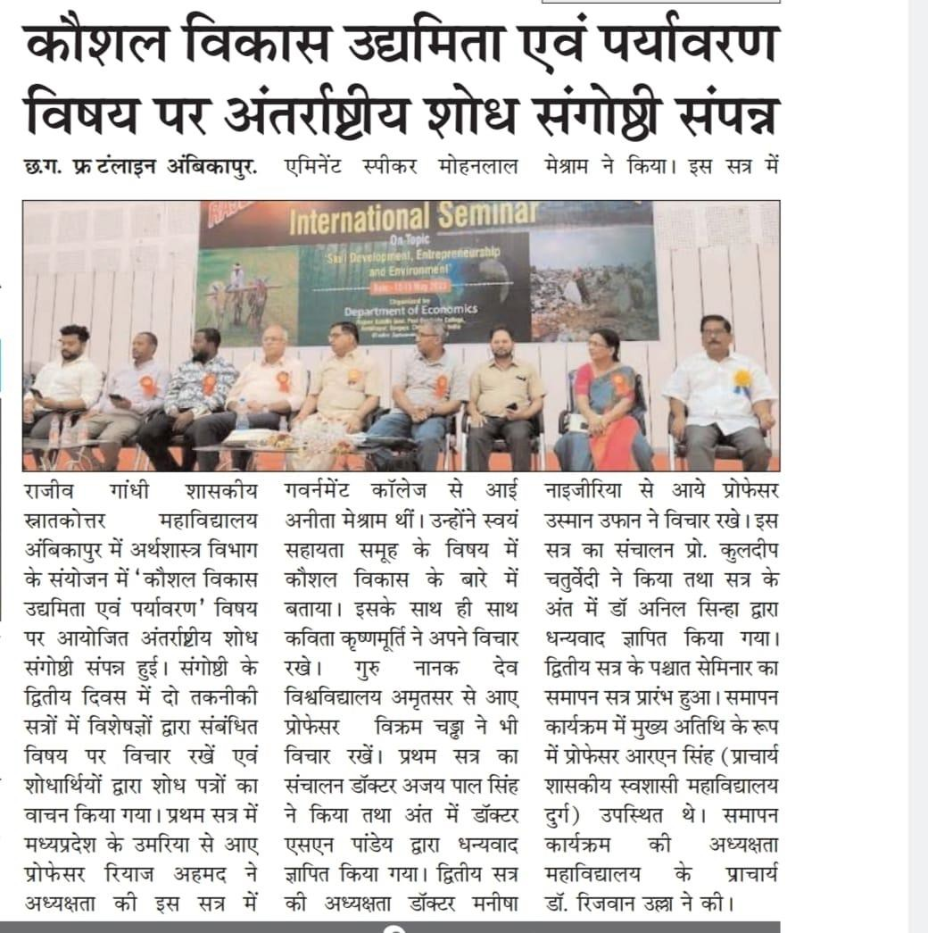

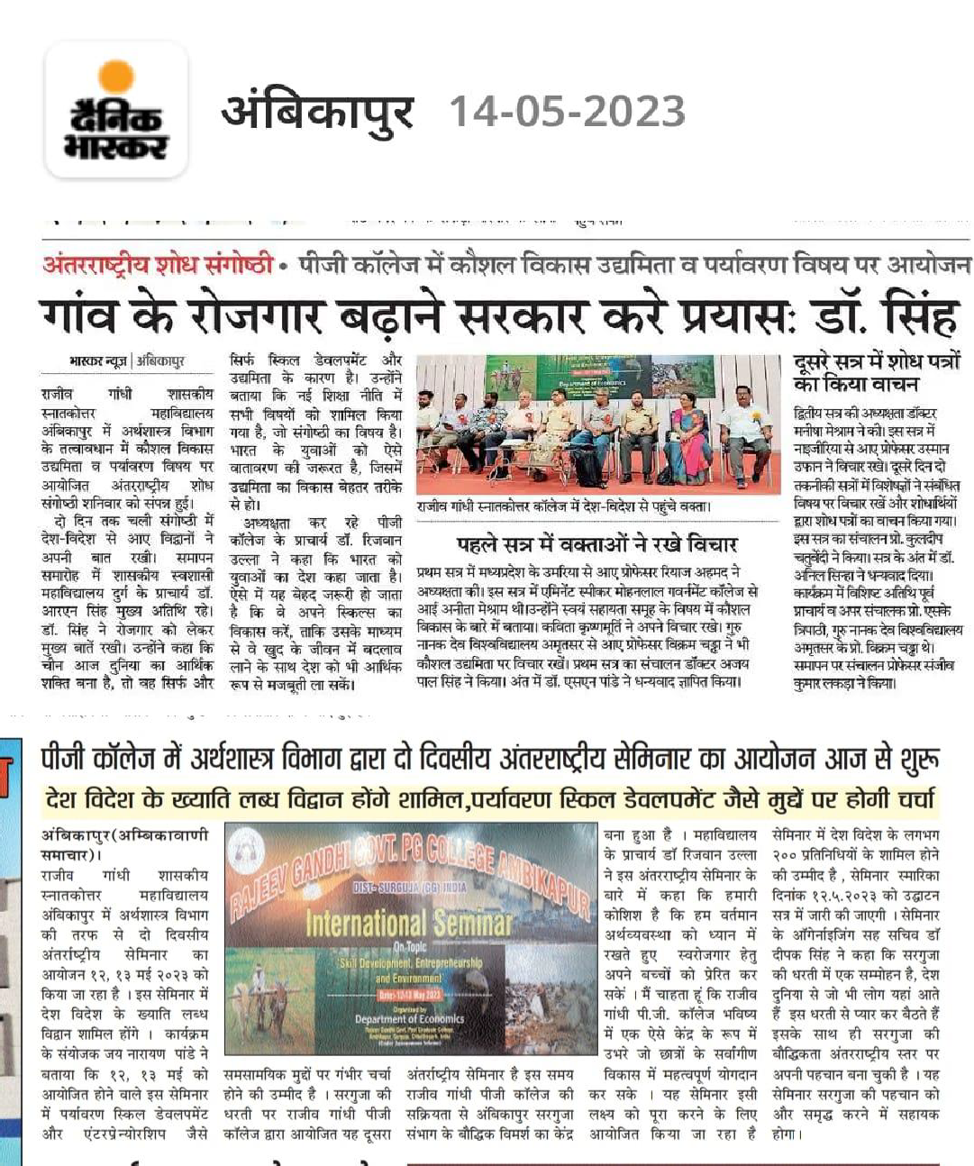

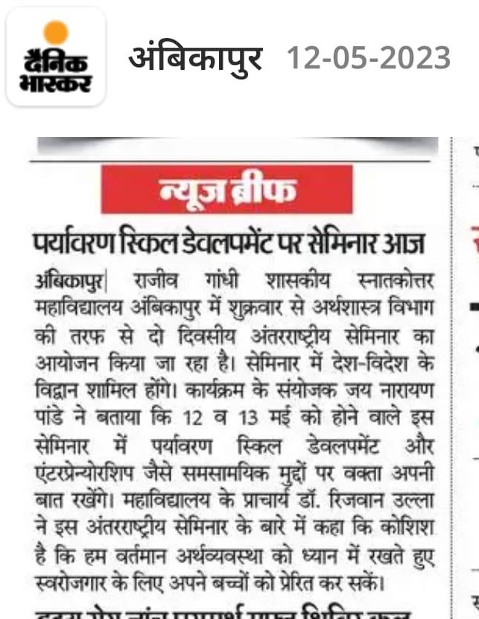

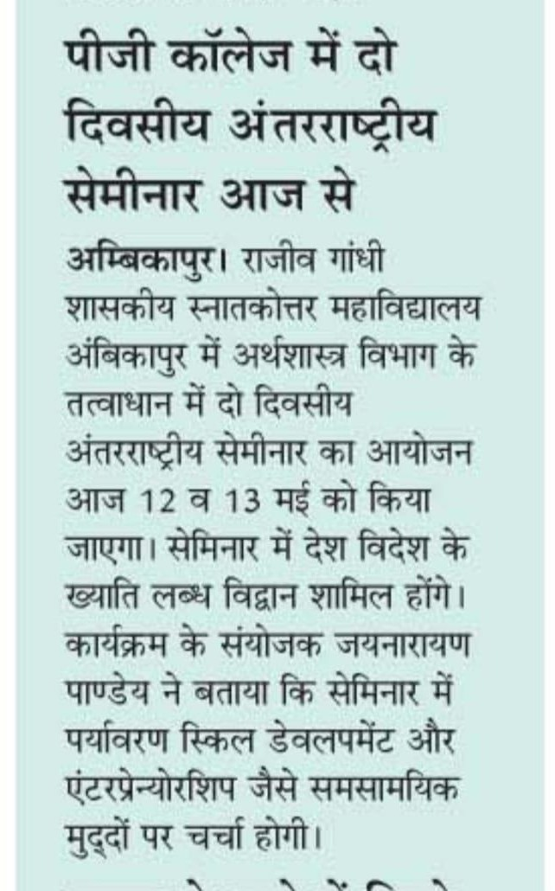

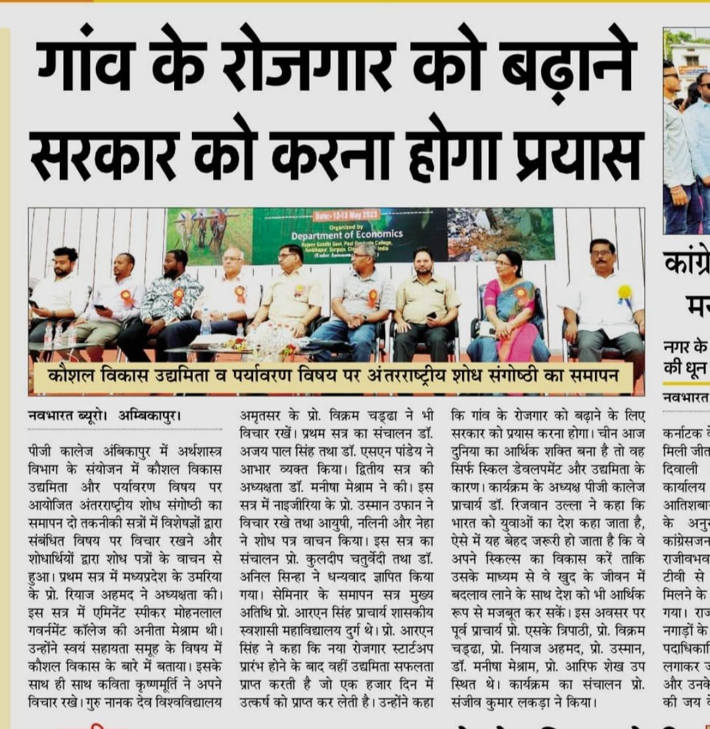

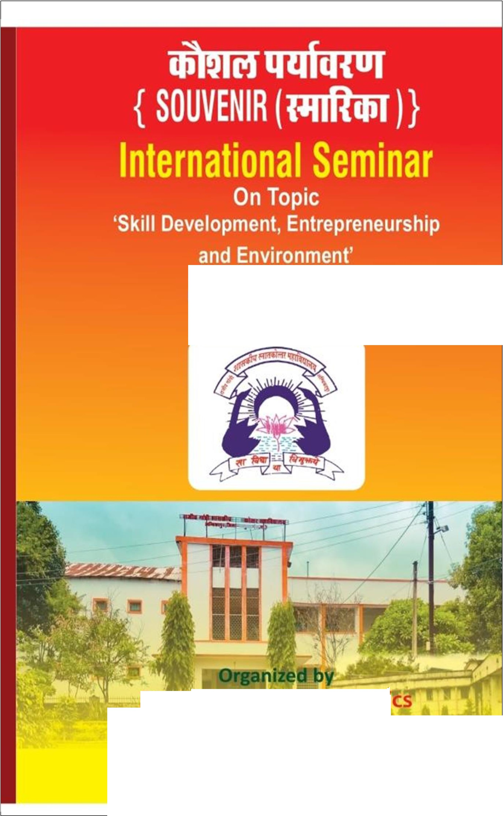

Date:-12&13May2023

De 'r c i
Rajeev Gandhi Govt. Post Graduate College Ambikapur,Surguja,Chhattisgarh
tIIIt·.\uoI ou t·u·J

34

